How to View a Video Conference

Quick Steps:

- Go to http://codianhd.oar.net/
- Select “ Streaming “ in top left corner
- Put 1234 in the conference ID space
- Click down arrow on Streaming Rate and choose QuickTime
- Click “Stream This Conference”
- A window to the conference will appear
  - Download Codec if needed.
- If you need technical assistance setting up your client machine please contact our service desk via email at support@oar.net or by calling 800.627.6420 and identify this as a streaming video issue for your workstation

Step by step directions with screen captures are provided on the following two pages.

- Go to http://codianhd.oar.net/
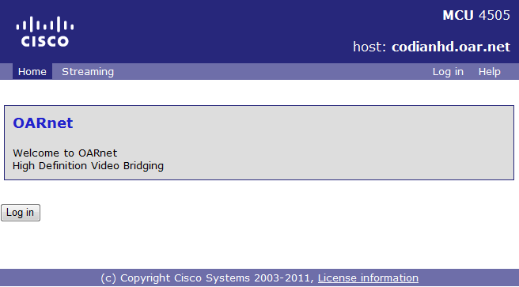
- Select “ Streaming “ in top left corner
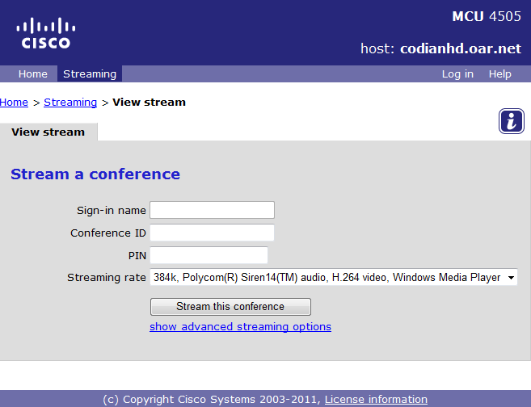
- Put 1234 in the conference ID space.
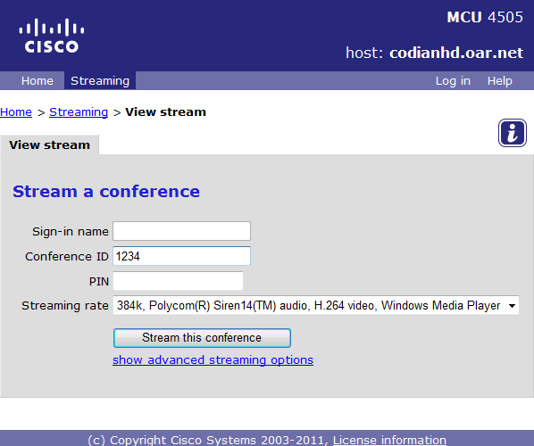
- Click down arrow on Streaming Rate and choose either QuickTime or Windows Media Player, which ever CODEC you normally use on your workstation
- Click “Stream This Conference”
- A window to the conference will appear. From here you will be able to view the video and hear the audio via your computer.
  - Download Codec if needed.
- If you need technical assistance setting up your client machine please contact our service desk via email at support@oar.net or by calling 800.627.6420 and identify this as a streaming video issue for your workstation

